Chapter 6

IMPLEMENTATION PLANNING
________________________________________________

6.1 IMPLEMENTATION ENVIRONMENT

The implementation view of software requirement presents the real world manifestation of processing functions and information structures. This computerized system is specified in a manner that dictates accommodation of certain implementation details.

The implementation environment of the developed system facilitates multiple users to use this system simultaneously. The user interfaces are designed keeping in mind that the users of this system are familiar to using GUI-based systems. Thus, we restricted ourselves to developing a GUI-based system so that it becomes easier for the end user to get acquainted to the developed system.

We have also followed the web based 4-tier architecture as the implementation architecture which is as follows:

The presentation tier or user services layer:
- This layer gives a user access to the application. It contains all the web pages so it is this interface through which user can access the application.
- This layer presents data to the user and optionally permits data manipulation and data entry.

The control tier or control layer:
- This layer gives a well separation between code and its connectivity with database.
- This layer includes the code (VB.NET code) and JS. Mainly this layer includes the replica of presentation layer pages and these pages are mainly control pages.

The business services layer:
- It consists of business and data rules. Also referred to as the business logic tier, the middle tier is where we as developers can solve mission-critical business problems and achieve major productivity advantages. The components that make up this layer can exist on a server machine, to assist in resource sharing. These components can be used to enforce business rules, such as business algorithms and data rules, which are designed to keep the data structures consistent within either specific or multiple databases. Because these middle-tier components are not tied to a specific client, they can be used by all applications and can be moved to different locations, as response time and other rules require.
- In our project we had created various classes appropriate to database and we implemented business logic here. According to request from presentation layer the appropriate rules called and it can access data through data tier.

The data tier or data services layer:
- This layer interacts with persistent data usually stored in a database or in permanent storage.
- In this layer we have implemented the basic function through data can be accessed like insert, update, delete, selection.
- Our Requirements are changing dynamically so we used four-tier architecture. The four-tier approach provides benefits such as reusability, flexibility, manageability, maintainability, and scalability.

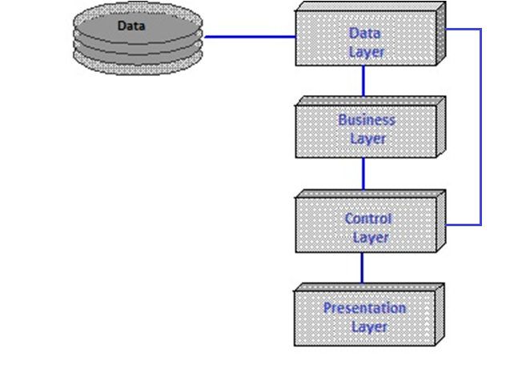

Fig 6.1 Four tier architecture

6.2 CODING STANDARTS

- Objects

The below are the naming convention for the design element used in the form.

Table 6.1 Naming Convention Table

Field type | Prefix | Example
Check Box | Chk | chkReadOnly
Combo Box  Drop-Down List Box | Cmb | cmbEnglish
Command Button | cmd | cmdExit
Common Dialog | dlg | dlgFileOpen
Data Grid | dgr | dgrOrderDetails
Date Time Picker | dtp | dtpDateOfBirth
Form | frm | frmEntry
Group Box | grp | grpPymntDtls
Horizontal Scroll Bar | hsb | hsbVolume
HTML/Frame | fra | fraLanguage
Image | img | imgIcon
Image List | ils | ilsAllIcons
Label | lbl | lblHelpMessage
Line | lin | linVertical
Link Label | lnb | lnbGotoWebSite
List Box | lst | lstPolicyCodes
List View | lvw | lvwFolderDtls
Main Menu | mnu | mnuFileOpen
Panel | pnl | pnlOrder
Picture Box | pic | pbxImage
Progress Bar | prg | pbrInstallProgress
Radio Button | rad | radSelect
Report | rpt | rptQtr1Earnings
Rich Text Box | rtx | rtxAddressDtls
Shape | shp | shpCircle
Status Bar | sts | staDateTime
Tab page | tpg | tpgPayerDtls
Text Box | txt | txtLastName
Timer | tmr | tmrAlarm
Tool Bar | tlb | tlbActions
Tool Tip | tip | tipTxtName
Vertical Scroll Bar | vsb | VsbRate
Regular Expression Validator | rev | revUserName
Required Field Validator | rfv | rfvUserName
Compare Validator | cmv | cmvStartDate
Validation Summary | vas | vasValidationSummary
Check Box List | cbl | cblDefectPattern

All Hidden Fields should be place one after the other to reserve the space in the form. Description & purpose of each hidden field should be documented in the design spec of the appropriate components.

- Variables

<prefix>_<meaningful name>
prefix : 2 character code.
First alphabet represents the scope of the variable
l - Local
g - Global
Second alphabet represents the type
b - Boolean
c - Currency
s - String
f - Float
i - Integer
l - Long
t - Time
a - Array
v - Variant
The body of the variable names and function names should use mixed case and should be as long as needed to describe their purpose. To keep the name length reasonable, abbreviations can be used for standard terms like Init for initialization, Tbl for table, Cnt for count, Grp for Group etc. Wherever abbreviations are used, try to use them consistently to improve readability. And in meaningful variable name variable name start with lower case salphabet and second part of the name should be start with upper case alphabet like for student name variable name should be studentName.
Recommended Maximum Length for variable names is 32 characters.

Example:
For declaring a global string variable for Group name: gs_grpName.

When passing values to a subroutine/function, use the same variable names in the called routine as in the calling routine.
For Functions and Subroutines
<prefix>_<meaningful name>
For Functions: prefix is fn

